The Gun
by Carol Ellis
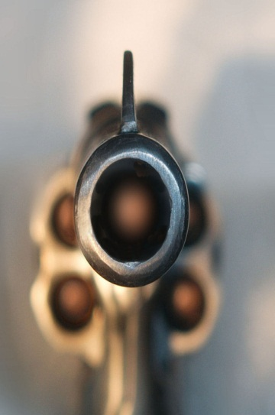
“He runs!” Derek said, dribbling the basketball down the cracked cement of the empty school yard. “He jumps!” Quick and agile, he side stepped his friend Jerry and leaped into the air. “He shoots, and---“ he watched as the ball dropped through the hoop, then finished his commentary with a grin “---nothing but net!”
“Nothing, but trouble, you mean.” Jerry grabbed the ball and tucked it under his arm. “Look over there.”
Turning, Derek saw two men coming through the gate of the school yard. It was a drizzly March day and both of them wore trench coats. Their faces were calm, and they walked casually, like maybe they were out for a stroll. But Derek knew they weren’t. Even before the taller one reached into his pocket he knew they were cops.
It was about the gun, Derek thought. It had to be. He felt panicky for a second, and had to remind himself that he’d thrown it away.
“Derek Robinson?” the tall one said.
“Yeah?”
“Detectives Kramer and Reed.” His hand came all the way out of his pocket and he flashed his badge. “Can we talk to you for a minute? We have a few questions.”
“What about?”
“Why don’t you step into our office?” Reed motioned to a bench on the other side of the school yard.
Derek’s heart sped up. Definitely the gun, he thought. With a quick glance at Jerry, he followed the officers across the yard and sat down on the bench. Kramer sat next to him. Reed stayed on his feet, looking around.
Kramer came right to the point. “It’s about the gun, Derek.”
Derek felt his face get hot, but he asked, “What gun?”
Kramer sighed. “The one you were flashing around in school yesterday.”
His eyes on the building across the street, Reed said, “And before that, the one Max Cooper saw you stuffing under your jacket.”
Max Cooper owned the deli that Derek passed every day on his way to school. Great, Derek thought. The guy had seen him.
“Plenty of people saw you with it,” Kramer said. “And we’ll find it, Derek, you can count on that. So do yourself a favor and cooperate.”
“OK . . .OK,” Derek said. “I had a gun.”
“Right. Where’d you get it?”
“I found it. In a lot.” Derek shook his head, remembering the fear and excitement he’d felt when he saw it. “I couldn’t believe it. A .38, just lying there!”
“You knew the caliber?” Kramer raised an eyebrow. “Where’d you learn about guns?”
“Where do you think? It’s not the first gun I’ve seen in this neighborhood.”
“Just the first one you found lying in a vacant lot.”
“Yeah.”
Kramer raised his eyebrow again. “So you took it to school?”
“Yeah. Look,” Derek said sitting up straighter on the hard bench. “It was dumb, OK? I know it. That’s why I got rid of it. I dumped it on my way home, right back where I found it.”

“Where’s this lot?” Reed asked, getting out a notebook.
“Corner of Fourth and Cooper,” Derek said. “Nothing there but weeds. That’s where I picked it up and that’s where I put it back. All you have to do is look and you’ll find it.”
“We’ll find it, all right,” Kramer said. “But let’s back up a little. You still had the gun with you after school. That’s what . . . three, three-thirty?”
Derek nodded. “Three.”
“So you left school. Then what’d you do?”
“Shot some hoops. Had some pizza,” Derek said. “The usual stuff.”
Reed slipped the notebook back in his pocket. “Does the usual stuff include holding up a hardware store at four-thirty?” His voice was quiet, almost conversational. But his eyes were as gray and chilly as the sky.
Derek’s face got hot again and his heart started hammering. He wanted to stand but he was afraid his legs might shake. “That’s crazy!” He wanted to sound cool, but he knew he sounded scared. “I never held up any hardware store! That’s crazy,” he said again.
“Seventeen or eighteen. Brown hair.” Kramer was reading from a little notepad. “About five-eleven, approximately a hundred and fifty pounds. Wearing jeans and a hooded, black-and-red Bulls jacket.” He stopped and eyed Derek’s jacket. “Black-and-white high-tops.” He glanced down at Derek’s shoes, then closed the notepad. “And carrying a .38 caliber revolver.”
“It fits pretty well,” Reed commented quietly. “Don’t you think Derek?”
Derek knew he didn’t have any reason to be so scared, but when he spoke, his voice shook. He couldn’t help it. “Yeah, it fits. But it wasn’t me. I had nothing to do with any robbery.”
“Maybe you didn’t,” Kramer admitted. “So let’s go back over what you did after school, OK?”
“I told you.” Derek looked at Jerry standing on the other side of the yard, shooting hoops and missing them all because he was keeping one eye on the little gathering by the bench. Suddenly, Derek’s fear left him. When he spoke again, his voice was strong and confident because he was telling the truth. “We left school at three,” he said. “We shot a few hoops, then we had some pizza.”
“We?”
“Me and Jerry.” Derek nodded towards his friend. “We had some pizza at Luigi’s, you can ask Jerry. That was about four.” He stood up now, knowing that his knees wouldn’t quiver like an old man’s. “And then we went down by the train tracks.”
There was a pause as the two detectives eyed each other. Then Reed asked, “With the gun?” His voice was quieter than ever.
Derek nodded.
“And what were you doing there?”
“Shooting at tin cans,” Derek said. He hadn’t told them before because he didn’t want to admit any more about the gun that he had to. But it didn’t matter now. They were after a hold-up guy; they wouldn’t care about a little target practice. Especially since Derek didn’t have the gun anymore.
“Let’s see if I’ve got this straight,” Kramer said. “You left Luigi’s and went to the train tracks and shot at tin cans with the .38 you found.”
“Yeah, it was about four-thirty, quarter to five.” Derek said.
“Did you shoot at anything besides tin cans?”
“Bottles and cans. That’s all.”
“Weren’t you afraid somebody would hear the gunshots?” Kramer asked.
Derek shook his head. “We waited for the trains to pass through.”
Kramer nodded. “Very clever. Did Jerry fire the gun, too?”
“No. Only me.”
“And then what?” Reed asked.
“When the gun was empty, we split. Jerry went home and so did I, “Derek told him. “And I threw the gun back in the lot where I found it.” He shoved his hands in his pockets. “Look, ask Jerry. He was with me at Luigi’s. Plenty of other people saw me there, too. And Jerry was with me at the tracks.”
“About four-thirty, quarter to five?” Kramer asked.
“Yeah.”
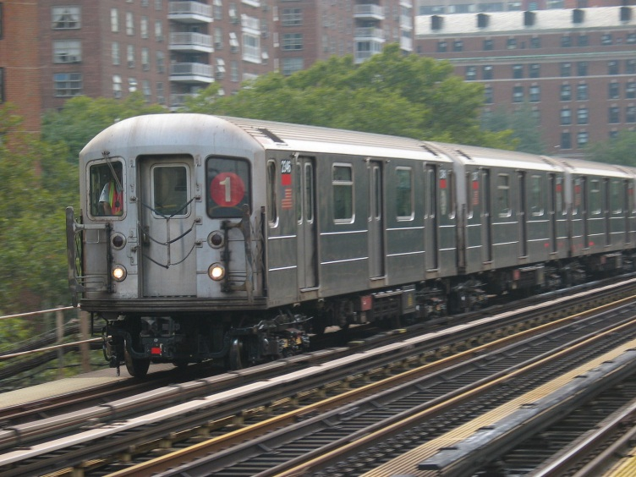
As Kramer got up from the bench and headed over to Jerry, Derek took a deep breath and let it out. He might still be in trouble about the gun. But no way could they pin the robbery on him. He hadn’t done it and he’d just proved it.
When Kramer came back, he nodded at Reed. “It checks out,” he said.
Derek let out a sigh of relief. “OK if I go now?”
“I don’t think so,” Reed said.
“But I told you what happened and you said it checked out!” Derek cried. “I didn’t rob anyone!”
“No, we know you didn’t,” Reed said.
“So?”
“So at four-forty yesterday afternoon, a stray bullet from a .38 caliber revolver smashed through the window of the D train and into the head of a young woman.” Reed looked at Derek with cold eyes. “You didn’t rob anyone, Derek,” he said. “You killed someone.”

