“Oranges”
By: Gary Soto
The first time I walked
With a girl, I was twelve,
Cold, and weighted down
With two oranges in my jacket.
December.
Frost cracking
Beneath my steps, my breath
Before me, then gone,
As I walked toward
Her house, the one whose
Porch light burned yellow
Night and day, in any weather.
A dog barked at me, until
She came out pulling
At her gloves, face bright
With rouge.
I smiled,
Touched her shoulder, and led
Her down the street, across
A used car lot and a line
Of newly planted trees,
Until we were breathing
Before a drugstore.
We
Entered, the tiny bell
Bringing a saleslady
Down a narrow aisle of goods.
I turned to the candies
Tiered like bleachers,
And asked what she wanted -
Light in her eyes, a smile
Starting at the corners
Of her mouth.
I fingered
A nickle in my pocket,
And when she lifted a chocolate
That cost a dime,
I didn't say anything.
I took the nickle from
My pocket, then an orange,
And set them quietly on
The counter.
When I looked up,
The lady's eyes met mine,
And held them, knowing
Very well what it was all
About.

Outside,
A few cars hissing past,
Fog hanging like old
Coats between the trees.
I took my girl's hand
In mine for two blocks,
Then released it to let
Her unwrap the chocolate.
I peeled my orange
That was so bright against
The gray of December
That, from some distance,
Someone might have thought
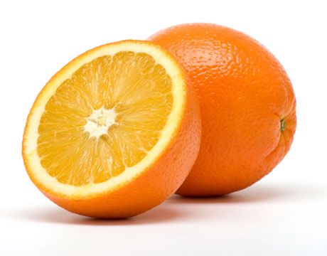
I was making a fire in my hands.

