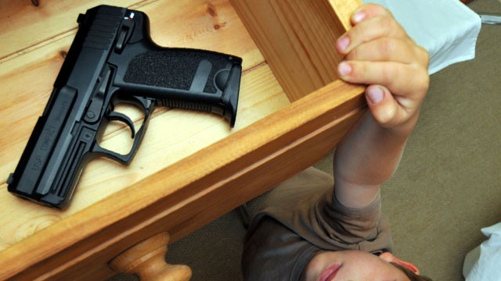
Kids, Guns, Negligent Homicides… And Double Standards
Michael Long | May 2, 2013

Our kids have made quite a few headlines this year. And not in a good way.
* * *
“A 5-year-old Kentucky boy who received a .22-caliber rifle as a gift accidentally shot and killed his 2-year-old sister on Tuesday…”
“A 5-year-old girl was shot and killed by her 8-year-old brother in Western Alaska Tuesday. The shooting happened as the boy was playing with a Ruger 10/22 rifle that he had used to go hunting the previous day…”
“A tragic accident involving a “cute” pink handgun occurred in Greenville, South Carolina on Friday. When police arrived, Tmorej Smith, 3, was found dead with a gunshot wound to the head…”
“A 14-year-old in Henry County, Georgia unintentionally shot and killed his 15-year-old brother early Saturday morning while playing with his mother’s gun…”
“A 6-year-old boy died Tuesday, a day after his 4-year-old neighbor shot him in the head with a rifle while the two were playing outside of a Toms River, NJ, home…”
“A three-year-old boy fatally shot himself with a gun he found in a car while his family stopped at a petrol station in the western US state of Washington, police say…”
* * *
Tragic? Of course.
But it’s also “predictable,” says Bryan Miller, formerly of the gun-violence prevention organization Ceasefire NJ. “So many people are negligent about storing guns when there are children around. So many parents say, ‘Oh I hide the gun. Jimmy doesn’t know where it is.’”
But the facts seem to say otherwise. As do the headlines.
Twenty-seven of America’s 50 states have laws to ensure that children cannot get access to firearms. These laws place the responsibility for safe gun storage — and legal liability for the consequences — on gun owners.
But that hasn’t stopped the carnage.
The reason for that is twofold. First, there are far too many conditions attached to these laws, making them unnecessarily complex and difficult to enforce.
Secondly, and perhaps more importantly, prosecutors are loath to charge and prosecute negligent parents. The common refrain being that the family has “suffered enough.”
And that’s true. They have.

Double Standards
But what’s the difference in terms of criminal negligence in the case where a parent leaves their child in a hot car during the middle of summer with the windows rolled up and the child subsequently dies from heatstroke?
Let one child die in an automotive oven and people are outraged. Leave a toddler next to a swimming pool while the mother is inside chatting on the phone? The same. Simply leave a child at home while a mother runs to the store, and it’s a case for child protective services to be called.
But let one child shoot another using an easily accessible firearm, and apparently the family has suffered enough. Or in the recent example of the Kentucky 5-year-old, dismissed by a state official as “Just one of those crazy accidents.”
Firearms, it would appear, are subject to a double standard.
An accident is slipping and falling down the stairs. Leaving a loaded gun in the corner of a room in a home with unattended preschoolers is negligence. Leaving a loaded weapon unattended in a nightstand is negligence.
And when a child is murdered by that gun it becomes negligent homicide.
It’s reported in this week’s Kentucky shooting that the parents indicated that they didn’t know the weapons was loaded. And yet isn’t the number one rule of firearm safety to always treat every weapon as if it’s loaded?
More to the point, if the gun was indeed “stored” by standing it in a corner of the room, then it was accessible not only by the 5-year-old, but by the 2-year-old as well.
And that’s negligence, pure and simple.

Accidents
CDC firearm accident data indicate that the number of children killed in accidental shootings increased from 68 in 2009 to 84 in 2010, reversing a 20-year decline. There were 851 accidental gun deaths of all ages in 2011, up from 606 the previous year.
Gun ownership had been in a generation-long decline, but the recent increase in sales and ownership numbers seems to have brought with it an increase in firearm accidents. And deaths. And these are just the accidents. How many teens commit suicide each and every year, on impulse, and with easy access to a parent’s gun? How many are taken to schools to “deal” with a problem?
And how many unsecured weapons are simply stolen?
Too many.

Solutions
So why are we not filing charges against negligent parents?
Why not have our states automatically file charges each and every time a child shoots and kills someone using an unsecured firearm?
Why not do it publicly, and why not get the media involved?
Speaking of which, why aren’t our gun safety organizations, including the NRA, running public safety spots on the dangers on having unsecured weapons in the home?
Why are we not working to stigmatize this behavior, just as we did with drunk driving?
And why are we not allowing doctors to ask about weapons in the home?

Welcome To GUNFAQ
GUNFAQ believes in the Second Amendment and the Constitutional right to bear arms.
We also believe, as do most responsible gun owners, that this right also comes with an equal, if not greater responsibility.
GUNFAQ’s aim to provide facts, with references, and with as little bias as possible.

Yes, we have a Second Amendment right to own weapons. Yes, we have a right to self defense. But that right also comes with a duty and a responsibility. And more to the point, our children have a right to live.
So let’s get the word out. And then perhaps a few more responsible gun owners will wake up and realize that lethal weapons need to be safely stored and secured and not just stood in a corner or tossed on a shelf or thrown in a drawer or stashed under a car seat.
Yes, it’s going to be tough on some people.
But so is burying a kid.

