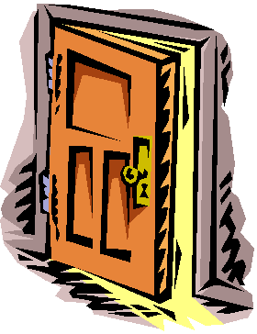
Brady’s Dilemma
A lot of Brady’s narration revolves around two tough questions:
“What if?”
and, “What should I do?”
After finding the drill inside the boat house, he is forced to decide on how to act. He must choose what to do in the wake of a horrifying realization, that what happened to Ben was no accident.
Every time someone makes a choice, it is like opening a door. For every door they open, there are a multitude of other possible doors they could have opened. Today, you will explore the doors Brady could open, and the positive and negative consequences of each potential choice.
Directions:
- Fold a piece of plain white paper in half along the horizontal edge.
- Fold it in half again, and then unfold it. You should have four equal rows on the piece of paper.
- Fold the paper along the vertical edge and leave it folded.
- Cut along the horizontal rows to the fold along one side.
- The end product should look like this:
(You should be able to open each flap like a door.)
You have now created four possible doorways that Brady could open at this point in the story.
- On the front of each door, write a choice Brady could make. (How might he proceed knowing what he knows at this point in the novel?)
- Draw a picture or design to accompany each choice. You could simply draw different doors, but think creatively of a way to connect them to the choice he could make.
- On the inside of each door:
  - Left Side (Label: Negative): Make a bulleted list of the negative consequences that could be results of the choice that corresponds with that door.
  - Right Side (Label: Positive): Make a bulleted list of the positive consequences that could be results of the choice that corresponds with that door.
- On the back of the set of doors, write your name, date, and class period.
Name: _______________________ Date: ________________ Pd. ______
The Choices of Three
Brady, J.T., and Digger all make choices throughout the novel Red Kayak that have dire consequences. Some of these choices result in Ben’s death. Others pull at the strings of fate that will or will not deliver justice. As you read, keep track of pages where each character makes a choice that deeply impacts the plot of the novel. Take notes as you see fit. You will use these notes in the final project for the novel.
Brady | J.T. | Digger
 |  | 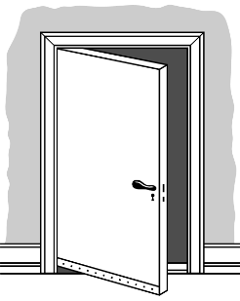
Name: _______________________ Date: ________________ Pd. ______
Culminating Project for Red Kayak
Assignment: Create a symbolic representation of how your assigned character’s choices impact the plot of the novel Red Kayak. Think cause and effect.
- Your project must show your character’s name along with a written or visual description of the character.
- Your project should depict at least 5 choices your character makes throughout the course of the novel.
- Each choice should be accompanied by a passage quoted directly from the text.
- Each choice should be followed by the consequences, or what happened as a result of the character’s choice.
- Your project should include some statement in writing of what legal consequences your character should face as a result of their involvement in Ben’s death. Use evidence from the text to support your decision here. (Basically, you are writing an A-C-E-C-E response here!)
Main Project Options:

- Three Dimensional Model
  - Mobile
  - Diorama
  - Sculpture
  - You Tell Me
- Two Dimensional Visual
  - Poster
  - Three-way display board
  - Painting/artwork
  - You Tell Me

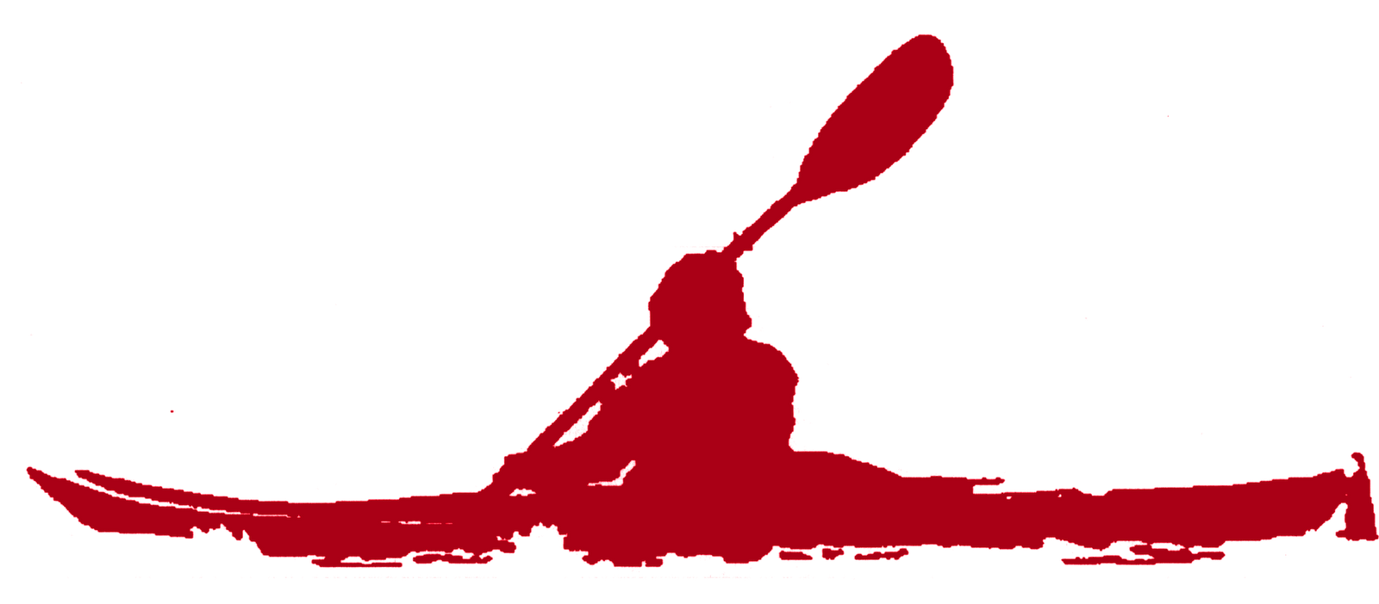
Oral Presentation: You must prepare a speech describing your symbolic piece that you will deliver in front of the class. The final oral presentation may not exceed 3 minutes and may not take less than 1 minute.

Student Name: ________________________ Due Date: __________________
Character Assigned: ________________________________
Scoring Rubric:
Element | Description of Requirements | Points
Quality | Student put great effort into the overall appearance and visual aesthetic of their final project. It is clear that the student devoted time and creativity to the product. | _____/10
5 Choices | Student chose events from the text that greatly impacted the plot. Their choices were accurate and not contrived. | _____/10
5 Quotes | Passage accurately reflects the choice a character made. | _____/10
5 Consequences | Student creatively and accurately depicted the consequences of the choice the character made. | _____/10
Final Legal Action | Student clearly and concisely explained in writing what legal action their character should face as a result of the choices they made. Their explanation included specific and relevant evidence from the text. | _____/10
Total |  | _____/40
Comments:

